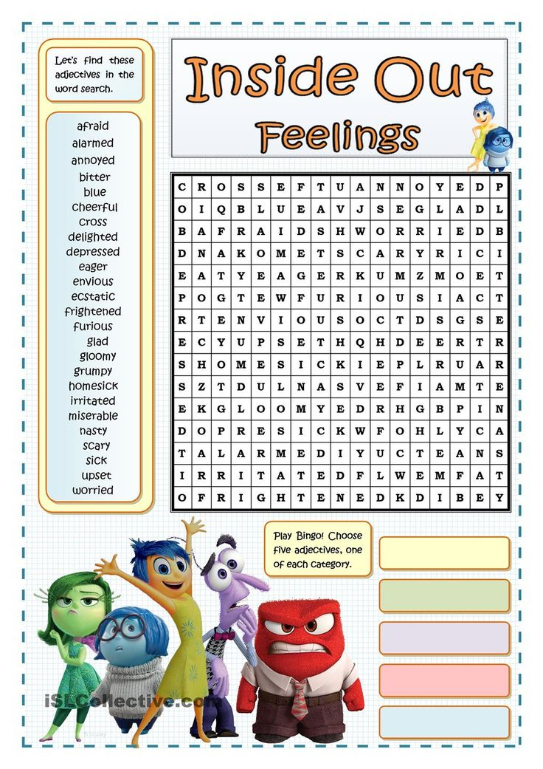
Name:__________________________________________ Date:___________________________

